To create a visual studio .net program in C or C++, first start Visual Studio.net.

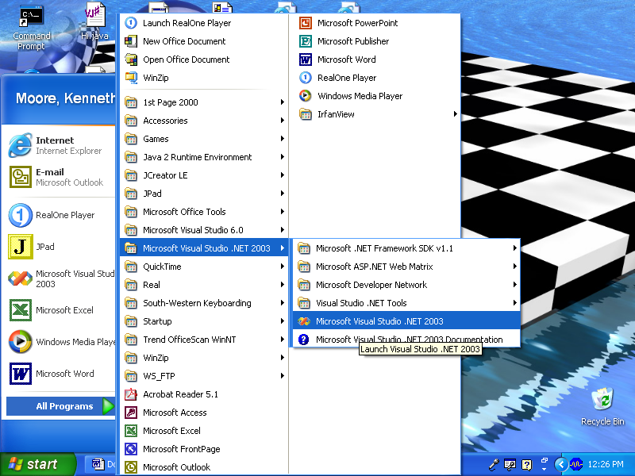

You will see something similar to this:

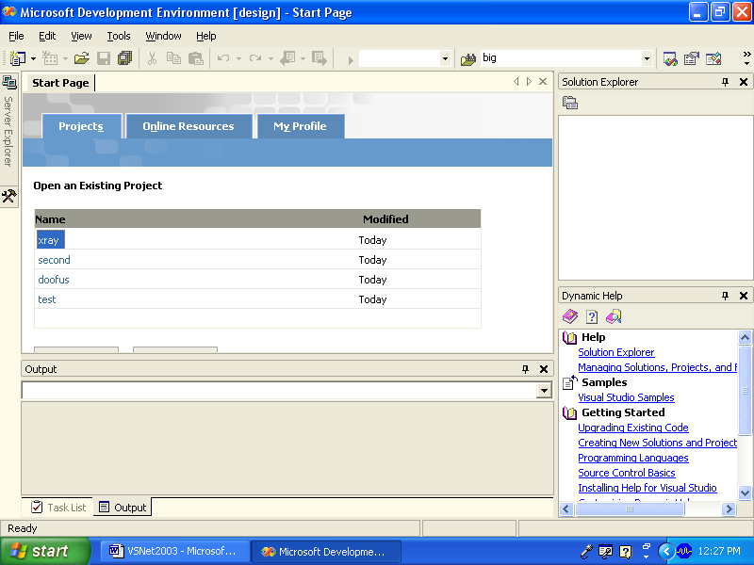

Select File/New/Project from the menu:
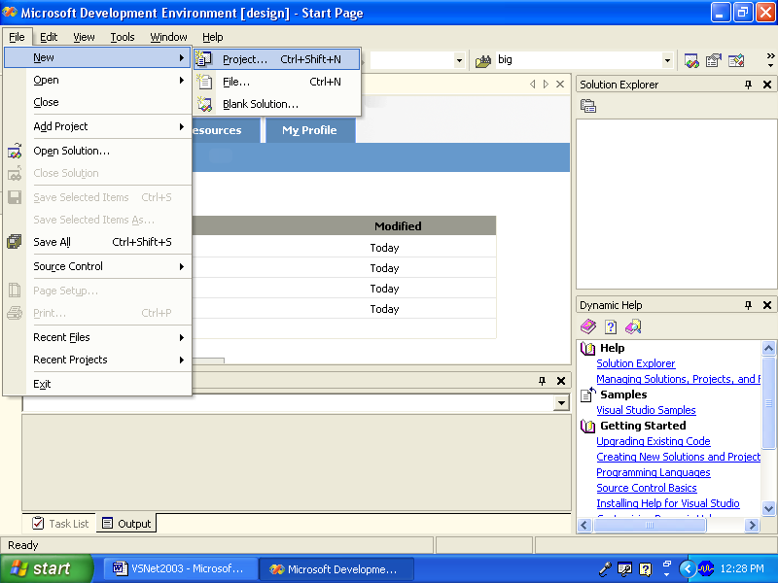

Select a C++ win32 console project

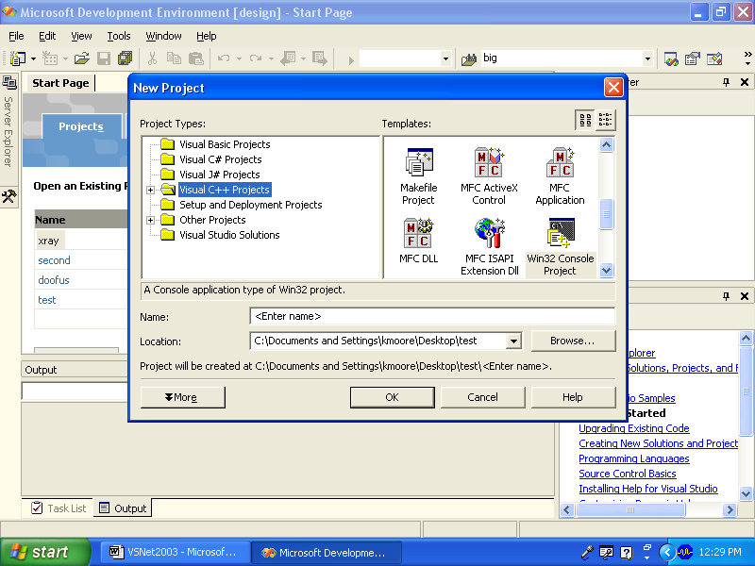

From the wizard chose the applications settings and check empty project:

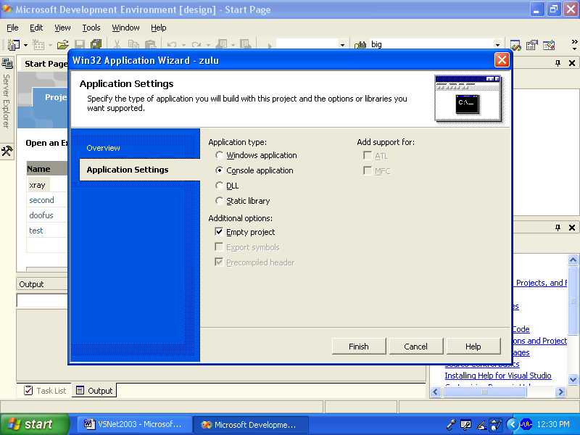

Then click finish.

If your solutions explorer is not visible, go to view and select solution explorer to get:

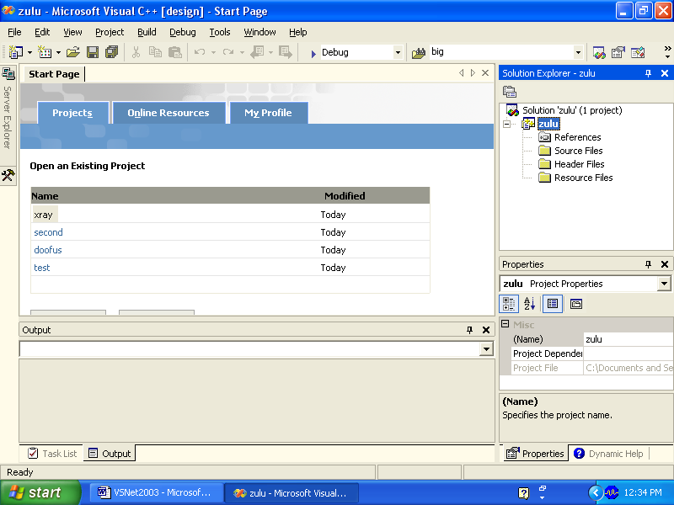

Now right click on the source file icon and chose the C++ option:

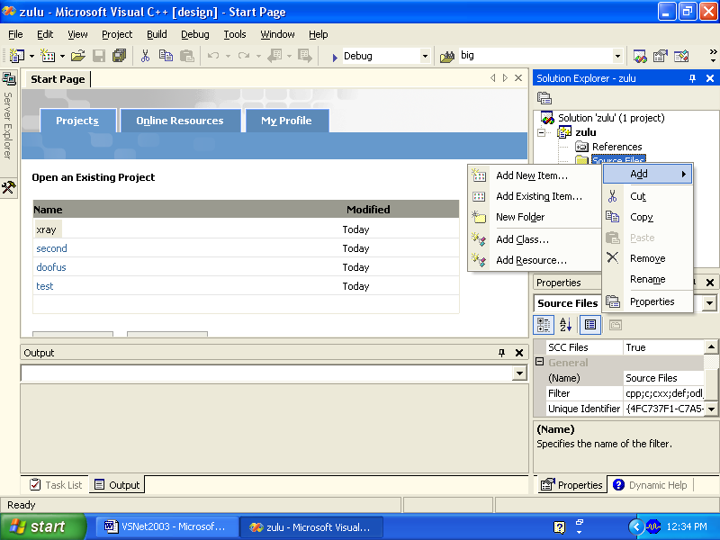

If you want a C file use a .c extension for the file name. If you want a C++ file use .cpp for the file extention.
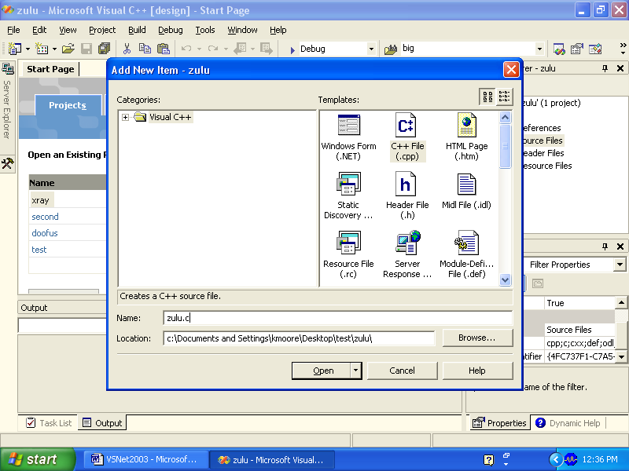

Click on the name of the file in the solutions explorer and you can enter your program.

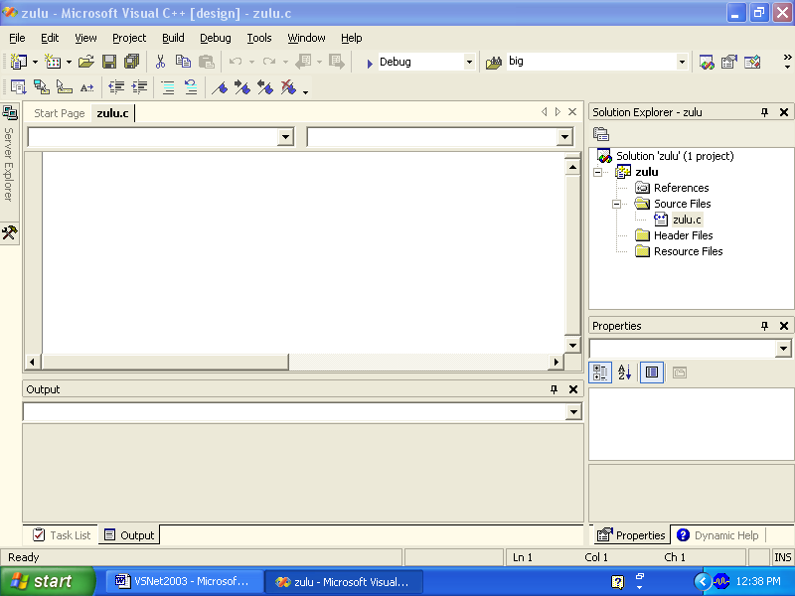

Here is an example of either a c or c++ source file:

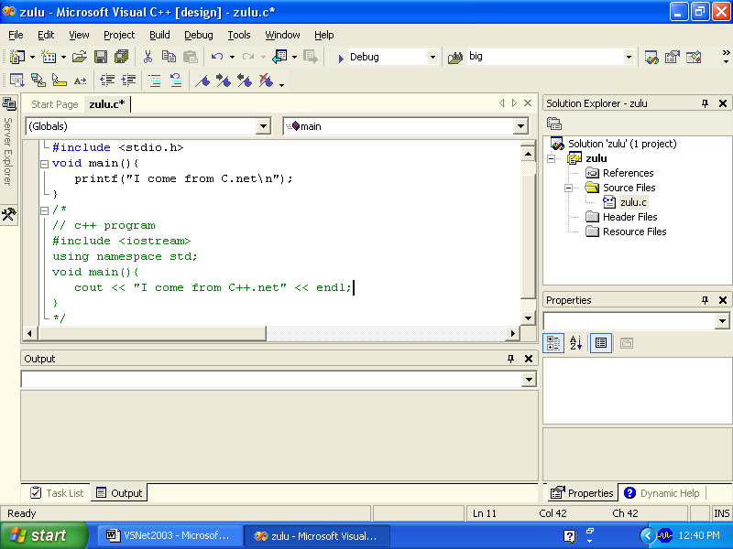

To execute the program go to Debug/run without debugging.
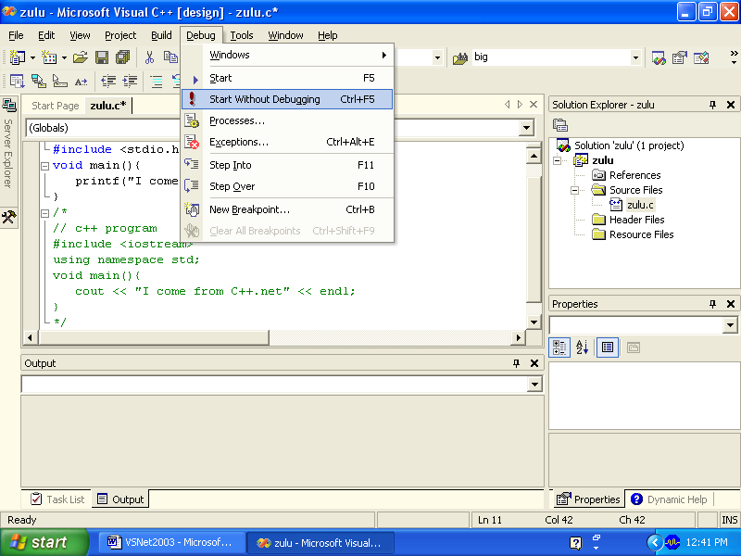

Enjoy! According to Ben Egan (my TA for this course), you may also just select an empty project at the beginning.

